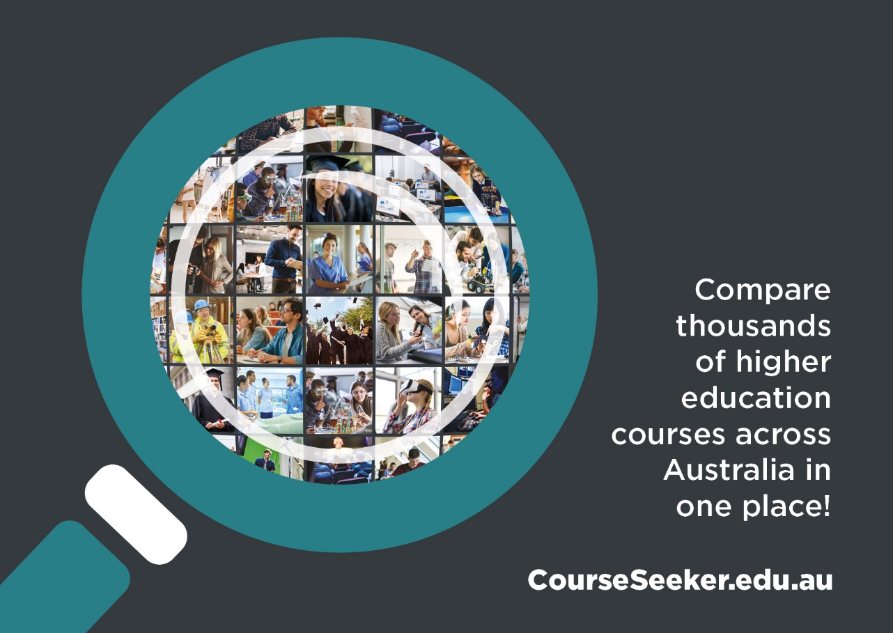
Compare thousands of higher education courses across Australia in one place!
CourseSeeker.edu.au
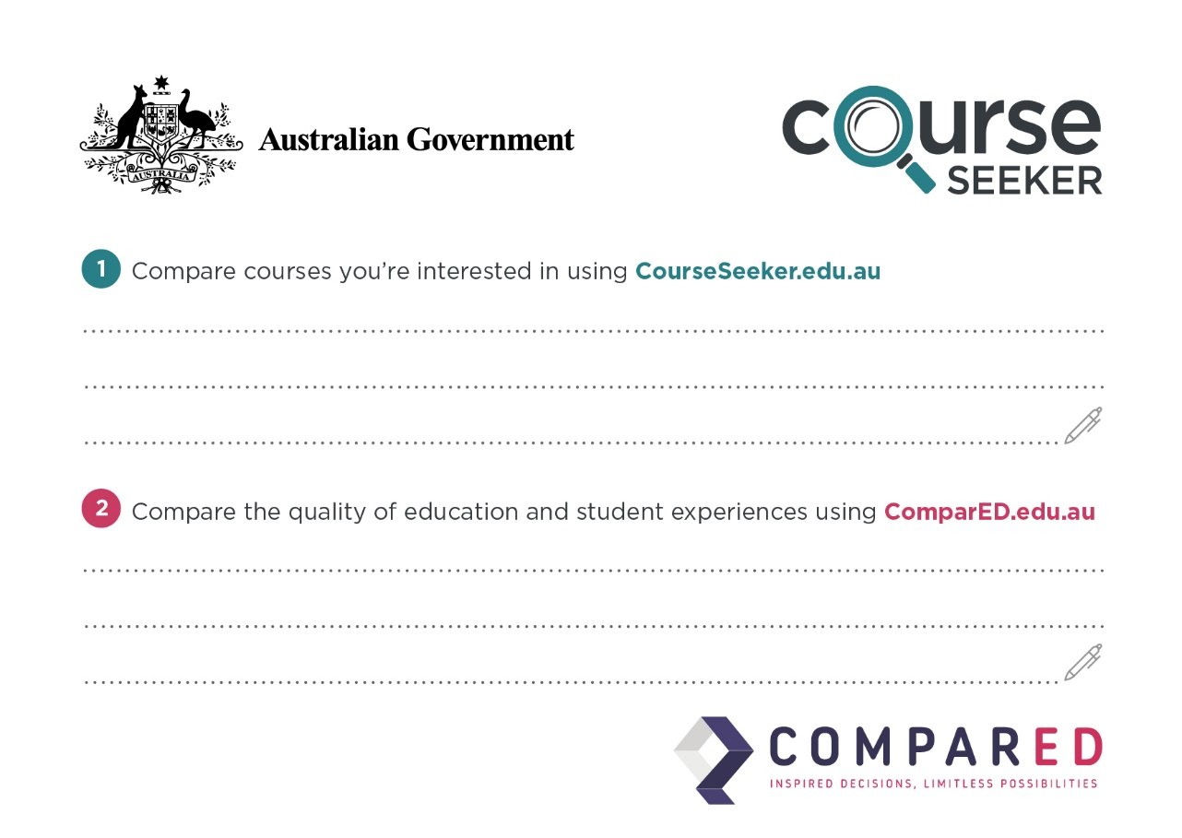
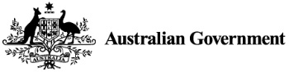
Compare courses you’re interested in using CourseSeeker.edu.au
Compare the quality of education and student experiences using ComparED.edu.au

